Covid Guidelines Policy

Venue: WHC Wrenn Astro

Completed by Paul Smith

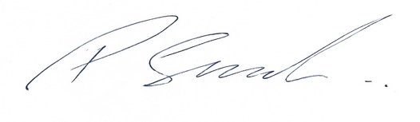

Date: 20/08/2020

Review Date: At each committee meeting and when England Hockey/Gov make changes to Covid-19 policy’s

WELLINGBOROUGH HOCKEY CLUB GUIDELINES - England Hockey Return to Play Step 4
18 August 2020

On 7 August, England Hockey moved to Step 4 of its Return to Play Roadmap, under Government guidance for a phased return to sport.
Step 4 of the Return to Play plan allows Local Match Play. Contact training in groups of up to 30, intra-club matches and local matches can take place. Restrictions currently prevent main competitions and leagues resuming. England Hockey will notify clubs when Step 5 - Full Competitive Match Play - is in place, and we’ll update everyone when it happens.
Here is what you need to know now, as a member, player, umpire or coach of Wellingborough Hockey Club... please read this carefully to ensure you can help keep yourself and other club members safe.
If you have any questions about these guidelines or returning to play, please contact WHC’s Covid Officer, Dave Langley, on dc.langley.hockey@outlook.com

TO DO NOW...

Decide if you’d like to get back to hockey at this time. WHC is arranging some hockey sessions that conform to the current guidelines; it is entirely up to you as to whether you’d like to participate. It’s a tricky time and you are not obliged to take part now if you feel it is not right for you.
If you would like to take part now... before attending your first training session or intra-club/local match, you must:
Ensure your name, email and contact number are up to date in WHC Teamer app if already a member/have an account. If you are new to the club and are wanting to become a member please complete request form http://tinyurl.com/y3putbta or contact us using https://wellingboroughhc.teamer.net/info
- Familiarise yourself with the guidelines for taking part: read the details below.
- Complete the online England Hockey Participation Agreement, making sure you pick Wellingborough hockey club as your organisation. You only need to do this once, before the first time you play.

Before every training session or intra-club/local match:

- Confirm your attendance with the session leader (i.e. the coach or captain who has invited you)
- Self-assess for symptoms of COVID-19:
  - You must not attend any session, as a player or spectator, if you have any of the following symptoms:
    - A high temperature / you feel hot to touch on the neck or back (above 37.8C
    - A new, continuous cough
    - Loss of, or change to, normal sense of taste or smell
  - Also, do not attend if you are feeling generally unwell, or if you have been in close contact with / living with someone with a suspected or confirmed case of COVID-19 in the previous 2 weeks.
- Get changed into your kit at home.
- Make sure you bring the following to the session for your own use:
  - Hand Sanitiser
  - Gum Shield
  - Shin Pads
  - Hockey gloves
  - Water bottle
  - Hockey face mask, if you have one
  - Face covering, if preferred (you are not obliged to wear a face covering during the session, but may feel you want to before/after the session, for travelling, using facilities etc. in accordance with current Government guidelines)
- If you need to travel to a session with others from outside of your household (e.g. share a lift or use public transport), please ensure you do so in accordance with current Government guidelines, as far as possible

During a training session or intra-club/local match:

- Follow signage at the venue: One-way system in place (Entry to pitch is Main double gates to pitch and Exit from pitch is Side gate halfway down the pitch)
- Register with the session leader on arrival, to ensure they are aware of your attendance
- Maintain social distancing before and after the session, in warm-ups and cool-downs (as far as possible) and during any breaks
- Regularly wash your hands / use your own hand sanitiser / use sanitiser at the venue
- Do not share or handle any equipment that is not your own (sticks, balls, shin pads, gloves, clothing, goalposts, cones, pitch markers etc.)
- Spectators must maintain social distancing and must not gather in groups of more than 6 people or enter the pitch at any time
- Please respect the welfare of others at all times. Do not spit, shout excessively (especially in face-to-face situations) or swill your mouth out / spit out water

If you become unwell:

If you feel at all unwell during a session, inform the session leader immediately.
If you have returned to play and you experience any COVID-19 symptoms or test positive for COVID-19 at any time, you must inform Wellingborough Hockey Club’s Covid Officer Dave Langley immediately on dc.langley.hockey@outlook.com
- The Club will get in touch with everyone who has attended the same session(s) as you, to make them aware and ensure they can follow Government guidance on self-isolating.
- The Club must report any suspected or confirmed cases of COVID-19 to England Hockey.
You must also get in touch with NHS Test and Trace.
Participant health and safety is of utmost importance: first aid will be available for injuries. Attendees should avoid crowding around an injured player; let the session leader deal with incident appropriately and only assist if you are a family member / share a household with the injured player, you are asked to assist or if emergency care is needed.

Junior/Badgers extra information:

Training:

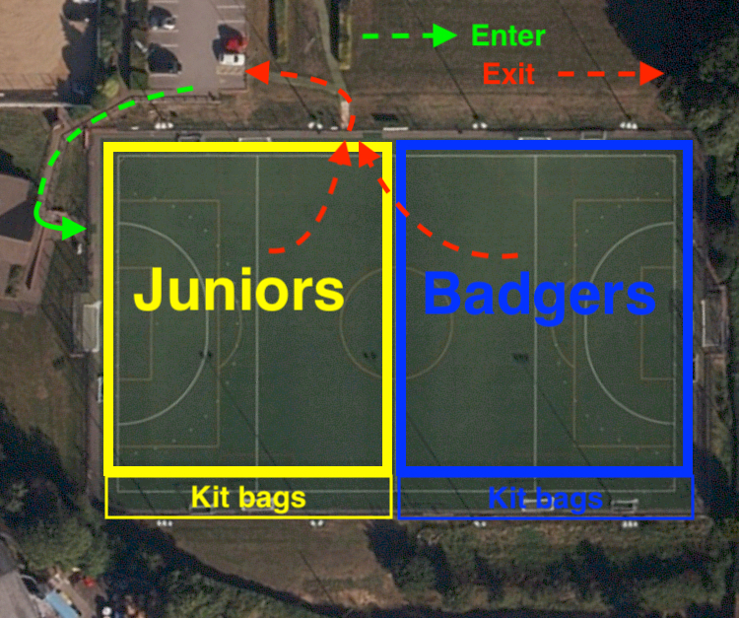

Junior/Badger sessions will start at 17:55-18:55 which gives time to make pitch safe and ready to use after junior session. The following protocols should be adhered to.

- Ideally, just one non-playing guardian/parent should be present with junior players aged 10 or younger, and must remain on-site at all times, observing social distancing
- Please register the junior’s attendance with the session leader. The Club will need to collect parent/guardian contact details for juniors attending the session
- Please ensure juniors are aware of and follow the guidelines for the session.
- Junior players aged 11 and above may be dropped-off in the main car park Please ensure juniors are aware of and follow the guidelines for the session, they know where to go, and they register with their session leader
- Players must not enter the pitch unless asked first (gate will be closed and opened only when safe to enter) When entering the pitch kit drop off point will be along the side of the pitch which is away from the car park (the first halve of the pitch will be for the junior’s and the second for the badgers).
- Keep any kit socially distanced from other players, ideally 2 metres apart
- Be ready to start the session, pads and gum shields fitted
- Wait ready for training instructions
- Guardian/parent of player (ideally same person as drop off) to be ready before session ends, near side gate to collect child

Adults extra information:

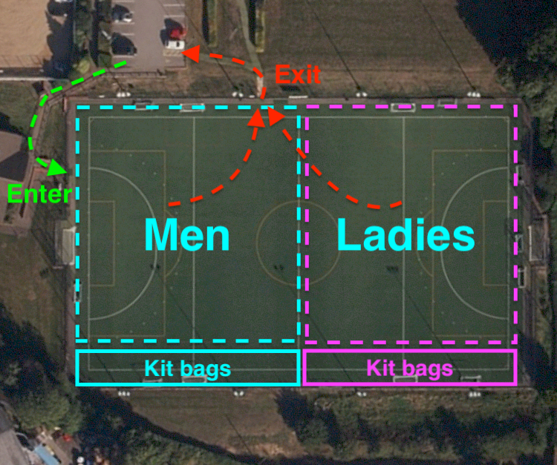

Adult sessions will start at 19:05-21:00 which gives time to make pitch safe and ready to use after junior session. The following protocalls should be adhered to:

- Players must not enter the pitch unless asked first (gate will be closed and opened only when safe to enter)
- If waiting to get on the pitch, please social distance and be patient
- When entering the pitch, the kit drop off point will be along the side of the pitch which is away from the car park (the first halve of the pitch will be for the men and the second for the ladies). Keep any kit socially distanced from other players, ideally 2 metres apart
- Be ready to start the session, pads and gum shields fitted
- Wait ready for training instructions

Match day:

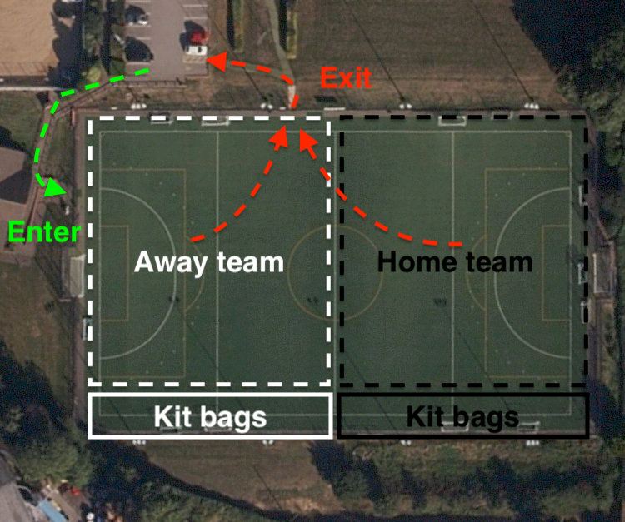

- Players are required to turn up to matches on time and dressed ready to play
- Showers will not be available to home teams until further notice (this allows traveling teams to be able to do so on busy match days)
- Teams can only enter the pitch when the pitch is clear/free of players/umpires from previous game
- Please leave the pitch in a timely manner after the game has finished so other teams can get on swiftly
- There will be no teas after the game as this is not possible yet due to numbers and space available (meeting room inside will be closed for such use)
- Home team will enter the pitch first and then the away team
- When entering the pitch, the kit drop off point will be along the side of the pitch which is away from the car park (the first halve of the pitch will be for the away team and the second for the home team). Keep any kit socially distanced from other players, ideally 2 metres apart
- Face guards can only be worn by the owner and not shared between players

PLEASE HELP US TO HELP YOU STAY SAFE

Please work with us to follow these guidelines, so that we can all stay safe.
We are keeping up-to-date with Government and England Hockey guidance and are prepared to change our activities if there are developments in the COVID-19 situation. We’ll keep all members, coaches and umpires fully informed of these changes through our social channels, by email and on Teamer.

Dave Langley, WHC Covid Officer
dc.langley.hockey@outlook.com
18 August 2020

IF YOU EXPERIENCE ANY COVID-19 SYMPTOMS, TEST POSITIVE FOR COVID-19, ARE CURRENTLY SELF-ISOLATING OR ARE LIVING IN A HOUSEHOLD WITH A POSSIBLE COVID-19 CASE PLEASE STAY AT HOME AND INFORM WHC’S COVID OFFICER IMMEDIATELY AT dc.langley.hockey@outlook.com

